HW1: (5倍分數)
You are an engineer who is responsible for designing a Windows-like GUI systems. You are developing the SDK for application programmers to develop applications under your GUI system.
The following Java example illustrates a base window class SimpleWindow. Soon, you find out that many other GUI components, such as vertical scroll bar, horizontal scroll bar, close button, min/max button (e.g., ) , etc. should be added to a SimpleWindow by programmer’s free will.
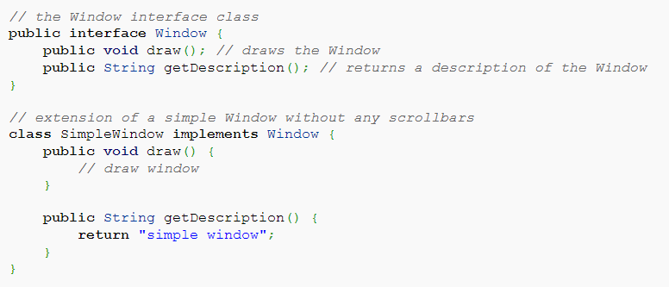
Your boss knows you are a design pattern expert because you should be well-trained from NCU CSIE. Please propose a good solution to your boss by:
- Draw UML diagrams
- Explain your solution
- Show sample code to demonstrate how application programmer can use your design to new an SimpleWindow, add a verticalscrollbar, and then add a closebutton.
A:
- UML diagrams:
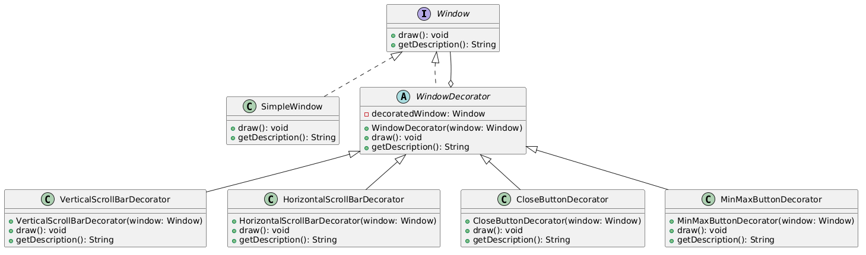
- Solution:
這個設計的核心想法是：所有視窗相關物件都實作同一個 Window interface，因此不管是原本的 SimpleWindow，還是加上 scrollbar、button 之後的視窗，在使用者眼中都還是一個 Window。
SimpleWindow 是最基本的視窗，只負責畫出基本視窗內容。
WindowDecorator 是抽象裝飾類別，裡面會保存一個 Window 物件。它本身也實作 Window interface，所以 Decorator 可以包住 SimpleWindow，也可以包住另一個 Decorator。
例如：
new CloseButtonDecorator(new VerticalScrollBarDecorator(new SimpleWindow()));

- Sample Java code:
// Window interface
public interface Window {
void draw();
String getDescription();
}

// Basic SimpleWindow
public class SimpleWindow implements Window {

@Override
public void draw() {
System.out.println("Draw simple window");
}

@Override
public String getDescription() {
return "Simple Window";
}
}

// Abstract Decorator
public abstract class WindowDecorator implements Window {

protected Window decoratedWindow;

public WindowDecorator(Window decoratedWindow) {
this.decoratedWindow = decoratedWindow;
}

@Override
public void draw() {
decoratedWindow.draw();
}

@Override
public String getDescription() {
return decoratedWindow.getDescription();
}
}

// Vertical Scroll Bar Decorator
public class VerticalScrollBarDecorator extends WindowDecorator {
public VerticalScrollBarDecorator(Window decoratedWindow) {
super(decoratedWindow);
}
@Override
public void draw() {
super.draw();
drawVerticalScrollBar();
}
private void drawVerticalScrollBar() {
System.out.println("Draw vertical scroll bar");
}
@Override
public String getDescription() {
return super.getDescription() + ", with vertical scroll bar";
}
}

// Close Button Decorator
public class CloseButtonDecorator extends WindowDecorator {

public CloseButtonDecorator(Window decoratedWindow) {
super(decoratedWindow);
}

@Override
public void draw() {
super.draw();
drawCloseButton();
}

private void drawCloseButton() {
System.out.println("Draw close button");
}

@Override
public String getDescription() {
return super.getDescription() + ", with close button";
}
}

// Application Programmer Usage Example
public class Main {
public static void main(String[] args) {

Window window = new SimpleWindow();

window = new VerticalScrollBarDecorator(window);

window = new CloseButtonDecorator(window);

window.draw();

System.out.println(window.getDescription());
}
}

HW2: (3倍分數)
想像一下，如果你”硬是”要將你的 UML editor 改成 MVC。請問一下你的 model 應該長成什麼樣子? 請寫個 class template, 幾個代表性的 API 就好。

A:
如果硬是要把 UML editor 改成 MVC，Model 不應該處理畫面，也不應該直接處理滑鼠事件。
Model 應該負責：
- 儲存 UML 圖的資料
- 儲存所有 UML shapes
- 儲存 class diagram 的 class、attribute、method
- 儲存 object relationship，例如 association、aggregation、composition、generalization
- 提供新增、刪除、修改、查詢 API
- 通知 View 資料改變了
- Model Class Template:
import java.util.ArrayList;
import java.util.List;

public class UMLDiagramModel {

private List<UMLShape> shapes;
private List<UMLConnection> connections;
private List<ModelListener> listeners;

public UMLDiagramModel() {
this.shapes = new ArrayList<>();
this.connections = new ArrayList<>();
this.listeners = new ArrayList<>();
}

// Add a UML shape into model
public void addShape(UMLShape shape) {
shapes.add(shape);
notifyModelChanged();
}

// Remove a UML shape from model
public void removeShape(UMLShape shape) {
shapes.remove(shape);
notifyModelChanged();
}

// Add a relationship between two UML shapes
public void addConnection(UMLConnection connection) {
connections.add(connection);
notifyModelChanged();
}

// Remove a relationship
public void removeConnection(UMLConnection connection) {
connections.remove(connection);
notifyModelChanged();
}

// Move a shape
public void moveShape(String shapeId, int newX, int newY) {
UMLShape shape = findShapeById(shapeId);
if (shape != null) {
shape.setPosition(newX, newY);
notifyModelChanged();
}
}

// Rename a class shape
public void renameClass(String shapeId, String newName) {
UMLShape shape = findShapeById(shapeId);

if (shape instanceof UMLClassShape) {
((UMLClassShape) shape).setClassName(newName);
notifyModelChanged();
}
}

// Add attribute to class
public void addAttribute(String shapeId, String attribute) {
UMLShape shape = findShapeById(shapeId);

if (shape instanceof UMLClassShape) {
((UMLClassShape) shape).addAttribute(attribute);
notifyModelChanged();
}
}

// Add method to class
public void addMethod(String shapeId, String method) {
UMLShape shape = findShapeById(shapeId);

if (shape instanceof UMLClassShape) {
((UMLClassShape) shape).addMethod(method);
notifyModelChanged();
}
}

// Get all shapes
public List<UMLShape> getShapes() {
return shapes;
}

// Get all connections
public List<UMLConnection> getConnections() {
return connections;
}

// Find shape by id
public UMLShape findShapeById(String shapeId) {
for (UMLShape shape : shapes) {
if (shape.getId().equals(shapeId)) {
return shape;
}
}
return null;
}

// Observer pattern for MVC
public void addModelListener(ModelListener listener) {
listeners.add(listener);
}

public void removeModelListener(ModelListener listener) {
listeners.remove(listener);
}

private void notifyModelChanged() {
for (ModelListener listener : listeners) {
listener.modelChanged();
}
}
}

- UMLShape Base Class
public abstract class UMLShape {

protected String id;
protected int x;
protected int y;
protected int width;
protected int height;

public UMLShape(String id, int x, int y, int width, int height) {
this.id = id;
this.x = x;
this.y = y;
this.width = width;
this.height = height;
}

public String getId() {
return id;
}

public void setPosition(int x, int y) {
this.x = x;
this.y = y;
}

public boolean containsPoint(int mouseX, int mouseY) {
return mouseX >= x && mouseX <= x + width
&& mouseY >= y && mouseY <= y + height;
}
}

當 Controller 接收到使用者操作，例如新增類別、移動圖形、建立連線時，Controller 不會直接修改畫面，而是呼叫 Model 的 API，例如：
model.addShape(new UMLClassShape("C1", "Student", 100, 100));
model.addAttribute("C1", "- name: String");
model.addMethod("C1", "+ getName(): String");
model.moveShape("C1", 200, 150);
Model 更新資料後，透過 notifyModelChanged() 通知 View 重新繪製畫面。這樣可以讓資料邏輯、畫面顯示、使用者操作分開，符合 MVC 的精神。

